Introduction to Spreadsheets for Data Analysis

**Introduction to Spreadsheets**

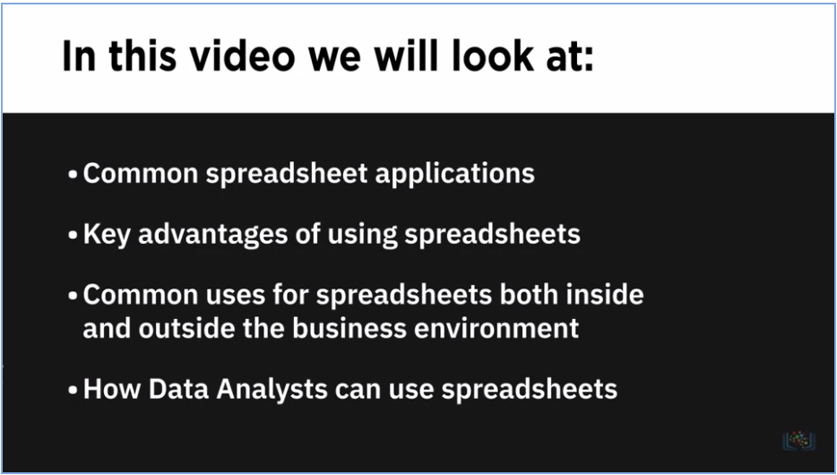

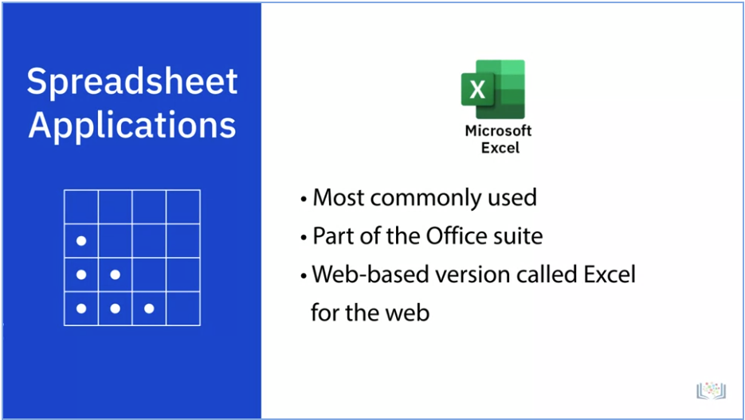

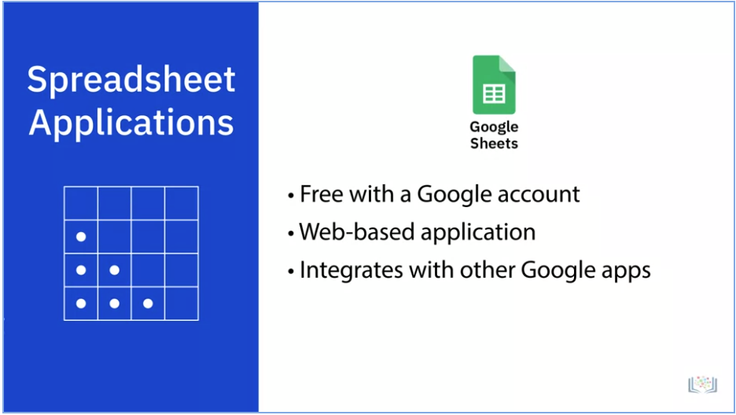

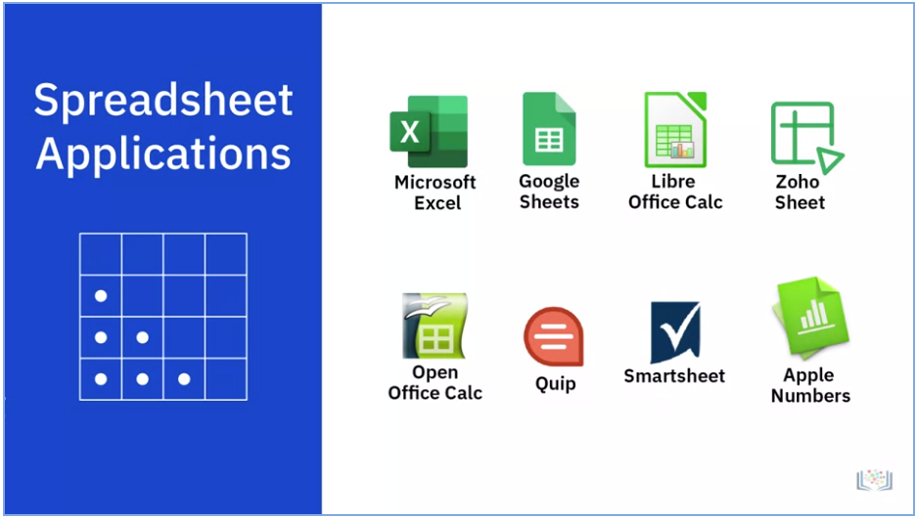

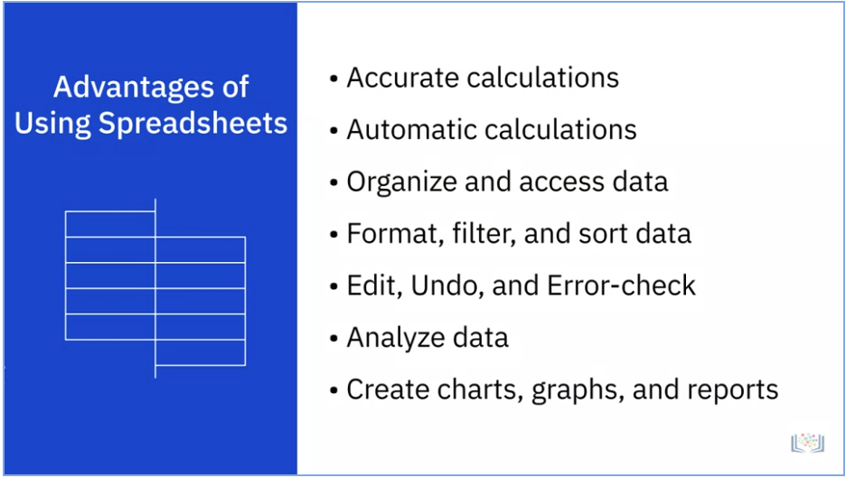

Since spreadsheet software for personal computers first appeared on the market in the 1970s, with VisiCalc on the Apple II PC, spreadsheets have come a long way in terms of the capabilities and features they now offer businesses, from uncomplicated tables and relatively simple computations to powerful tools for the analysis, management, and visualization of enormous sets of data.

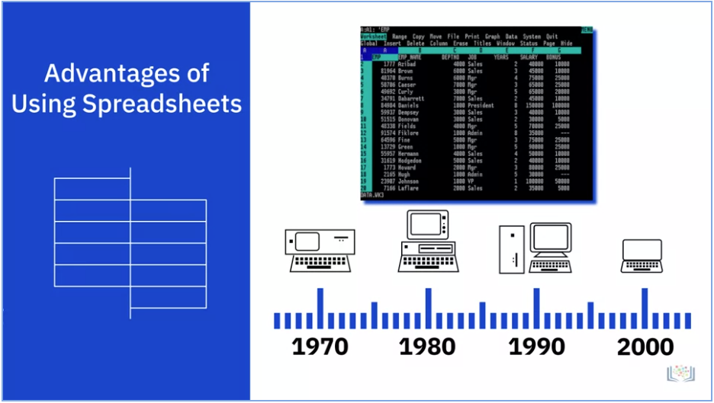

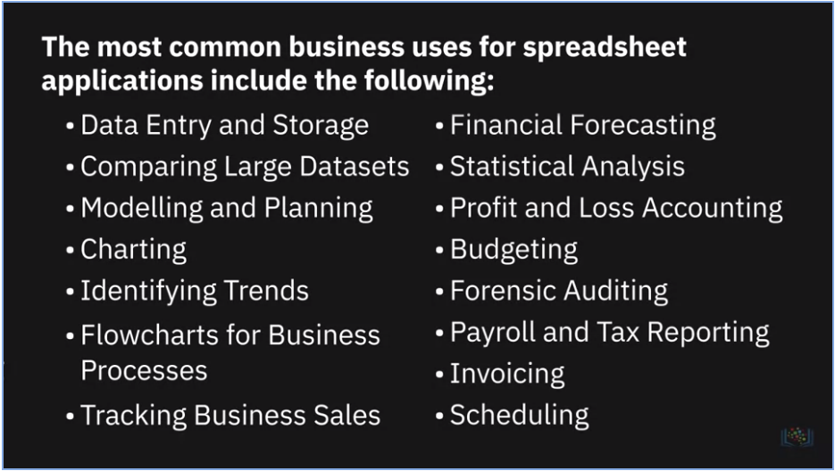

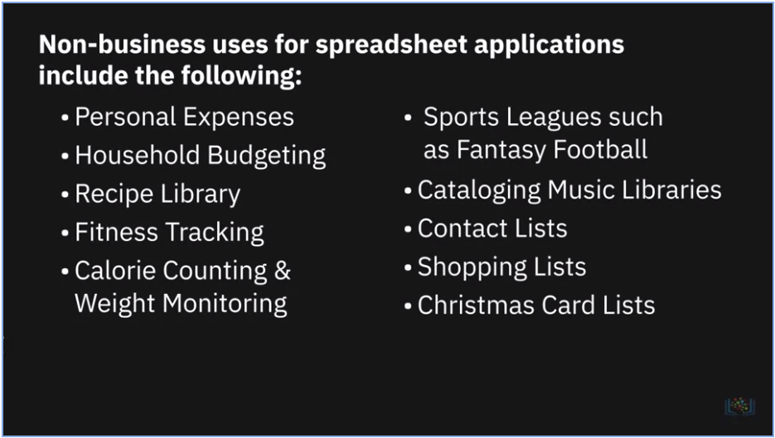

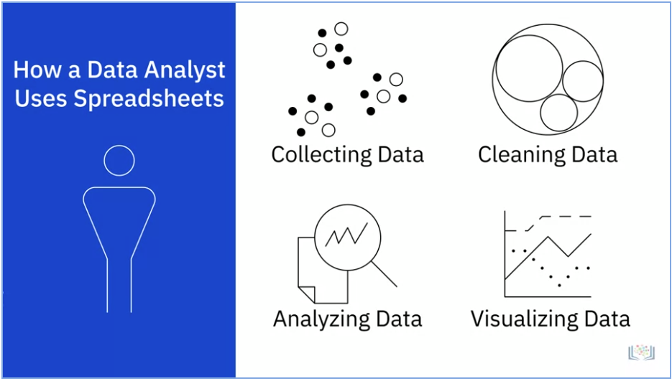

**Spreadsheet Basics**

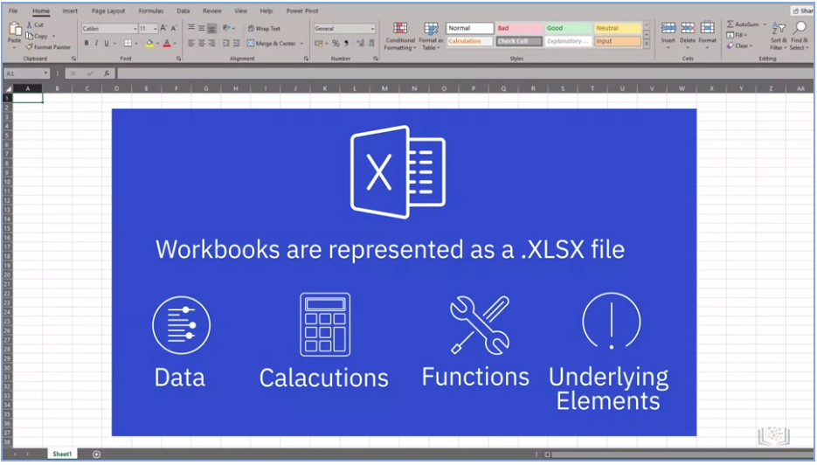

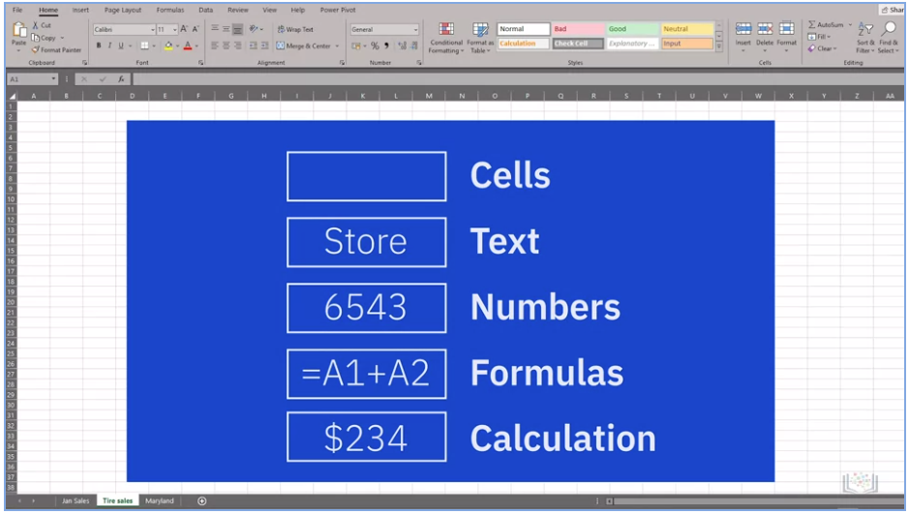

**Excel Keyboard Shortcuts**

|  |  |
| --- | --- |
| **Task** | **Shortcut** |
| Close a workbook | Ctrl + W |
| Open a workbook | Ctrl + O |
| Save a workbook | Ctrl + S |
| Copy | Ctrl + C |
| Cut | Ctrl + X |
| Paste | Ctrl + V |
| Undo | Ctrl + Z |
| Remove cell contents | Delete |
| Bold | Ctrl + B |
| Open context menu | Shift + F10 |
| Expand or collapse the ribbon | Ctrl + F1 |
| Move up one cell in the worksheet | Up arrow key |
| Move down one cell in the worksheet | Down arrow key |
| Move one cell left in the worksheet | Left arrow key |
| Move one cell right in the worksheet | Right arrow key |
| Move to the edge of the current data region in the worksheet (e.g. end of column) | Ctrl + Arrow key (e.g. Ctrl + Down arrow) |
| Move to the last cell on a worksheet | Ctrl + End |
| Move to the beginning of a worksheet | Ctrl + Home |
| Extend the selection of cells to the last used cell on a worksheet (lower right corner) | Ctrl + Shift + End |
| Move to the cell in the upper-left corner of the window (when Scroll Lock is On) | Home + Scroll Lock |
| Move one screen down in a worksheet | Page Down |
| Move one screen up in a worksheet | Page Up |
| Move one screen to the right in a worksheet | Alt + Page Down |
| Move one screen to the left in a worksheet | Alt + Page Up |
| Move to the next sheet in a workbook | Ctrl + Page Down |
| Move to the previous sheet in a workbook | Ctrl + Page Up |
| Edit the active cell and put the cursor at the end of the cell's contents | F2 |
| Enter the current time | Ctrl + Shift + colon (:) |
| Enter the current date | Ctrl + semi-colon (;) |

**Using Spreadsheets as a Data Analysis Tool**

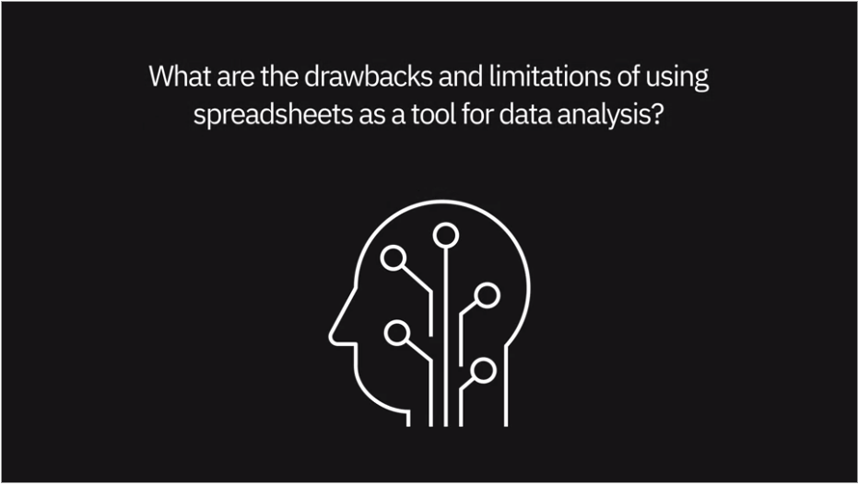

* One of the big cons in terms of analyzing data within spreadsheets is it's **really hard to reproduce state**. So, in other words, if you load in some data and you filter out some bad values, or you impute some missing values, **there's no way to tell your colleagues or your future self exactly the different steps you took** to create that data set or to modify that data set.
* It's almost a dilemma because of the **plethora of options available within Excel** and all of the functions that are there, supposedly to make your life easier, but **it's nearly impossible to know everything**.
* You can find yourself in what we call “analysis paralysis” when you're looking at something for too long or you're not well-versed in a particular Excel function. So, you may spend a lot more time, energy, and effort trying to figure that one thing out. And had you done it a different way? Or maybe a manual way? You probably could have gotten to the solution a lot easier.
* If you have complex formulas, VLOOKUPs, IF Statements at times they just stopped working and you have to rebuild them. So, I have found that it's better to use Excel just for simple analysis and for a download of information.
* If we start to get over 20,000 lines of data, it gets a little tricky. And sometimes the spreadsheets will crash. So that's when we might move to Access and some of the other tools that we use. Is very difficult to handle the extremely large data set in spreadsheets. Besides spreadsheets have less flexibility for complicated analysis and presentation.

**Summary and Highlights**

In this lesson, you have learned:

* There are several spreadsheet applications available in the marketplace; the most commonly used and fully-featured spreadsheet application is Microsoft Excel.
* Spreadsheets provide several advantages over manual calculation methods and they help you keep data organized and easily accessible.
* As a Data Analyst, you can use spreadsheets as a tool for your data analysis tasks.
* There are several elements that make up a workbook in a spreadsheet application.
* The ribbon provides access to all the features and tools required to view, enter, edit, manipulate, clean, and analyze data in Excel.
* There are several ways to navigate around a worksheet and workbook in Excel.